Toolboss instructions

Start ToolBoss Utilities

To add a tool, click on System Configuration on the left column, then click on Machine Setup in the right column

User – admin

Password – sps

Double Click the ITEMS icon

Try to copy an existing tool and just modify it, sometimes is just quicker to do. You can scroll down or there is a search box on the top by the magnifying glass and you could start typing a part number to search for.

You can always click on the Column name to sort by that also if you are looking for a particular type of tool to copy also.

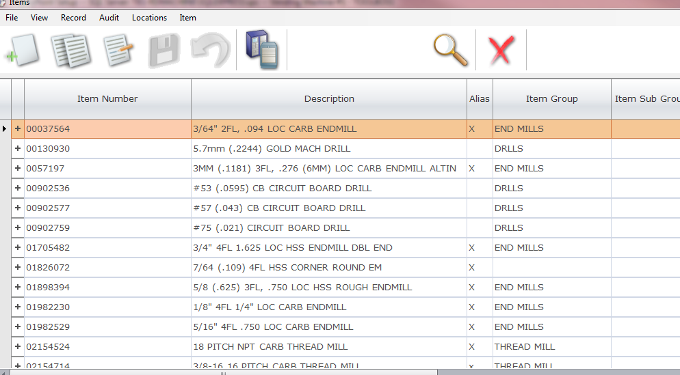

Once you find a tool to copy, highlight it and click the second icon on the top bar with the double document

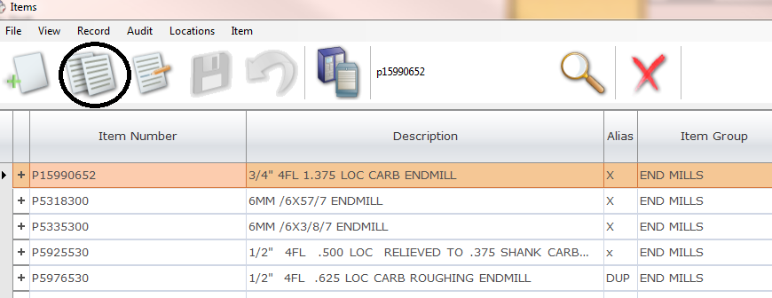

In the rows enter the new part number, Description, Item Group, Supplier if listed and any cost if you know it. When all entered click the Save Icon on the top bar.

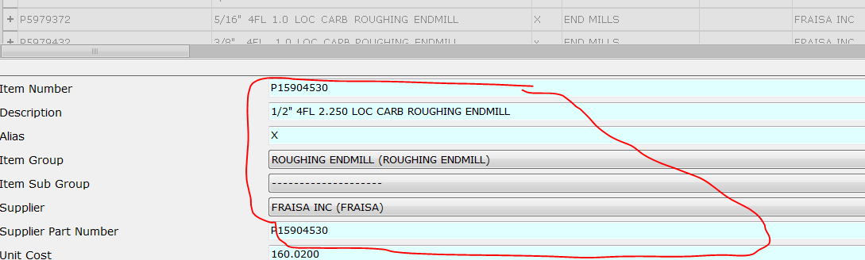

Once you click save, this window will pop up. check the box by “1- Tool Boss” and click ok

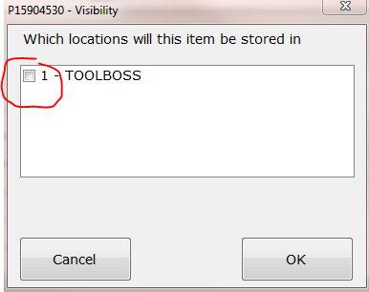

Once you click Ok, this window will pop up. enter the Min Qty, Max Qty, and check the box, Can Be Returned. Then click the Save Icon.

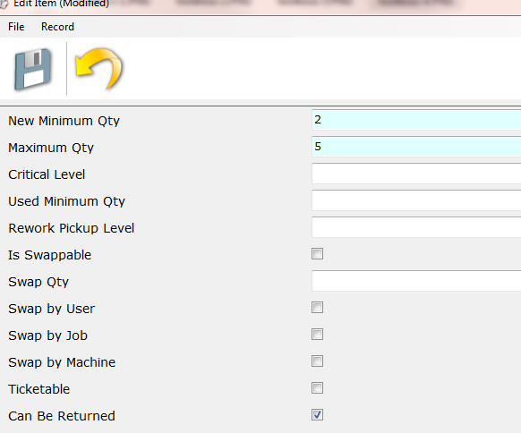

Now the tool is entered. Now search for it in the top bar. Once you SINGLE click on the line, it will display everything about the part number in the area on the bottom. Keep this window open this way it is and now start Global Shop

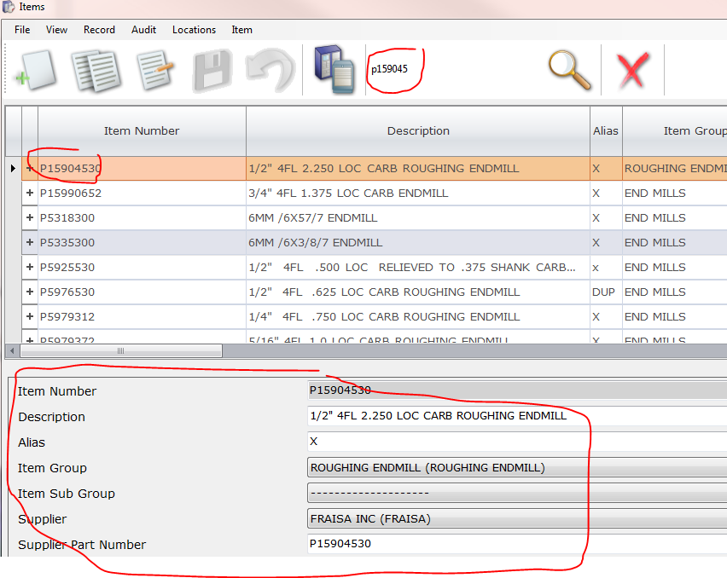

Start Global Shop and go to Inventory > File > Inventory Parts > New

Now either copy all the text for the part from the Toolboss screen or re-type it. I would prefer to copy it not re-type to avoid any mistakes.

On ToolBoss you have to highlight the part number and RIGHT CLICK to copy it.

Copy the part number, Enter PT for Product line, Copy the Part Description, enter the U/M, Source, Bin set to TBOSS, enter price if known, Purchase unit of Measure (if you buy in package quantity) Lead Time to get the tool, and the Order Quantity you want to buy (this is just going to populate the PO and can be changed if you want at PO time. On the bottom REORDER POINT, set this to 1 (one) less than the MIN quantity you set in toolboss. So if you entered 2 in toolboss in Global you want it at 1.

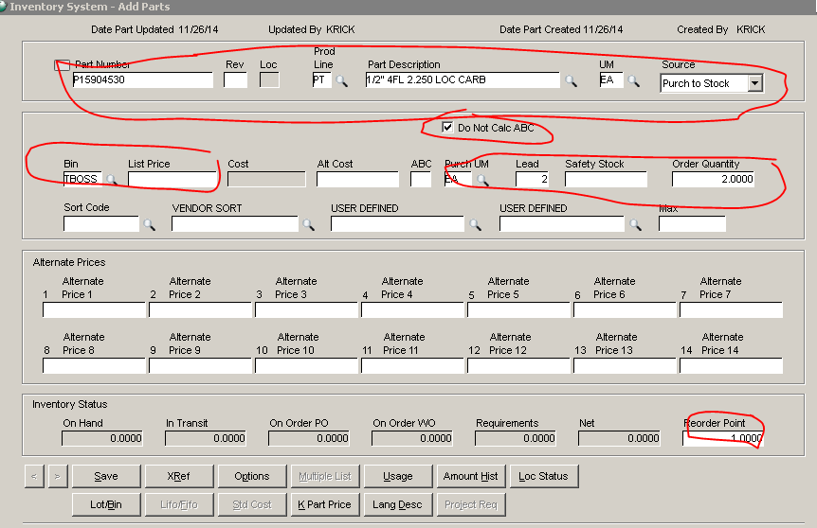

Now click the X-Ref button

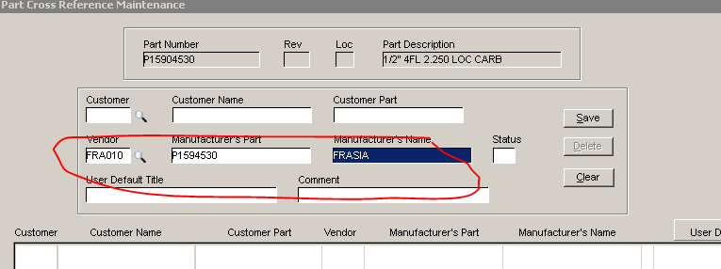

Enter the Vendor their part number if different and the manufacturers name. Then click Save and close this window.

Now click the Options Button and fill in the stocking Bin to TBOSS and click OK

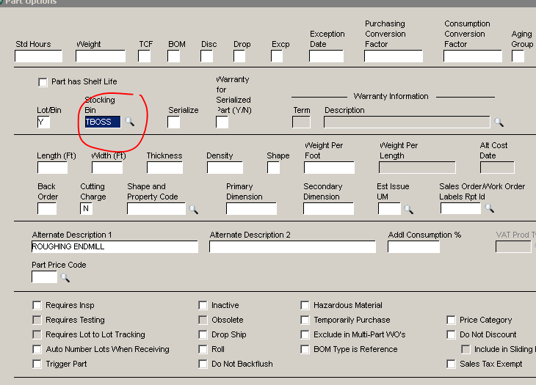

Now click save to save the part.

Now you have to adjust the inventory to the correct quantity you have in stock and add the lot/bin location

Go To Inventory > Transactions > Physical Inventory. When the posted date screen opens just click ok.

Search for your part number – Click the Add button below

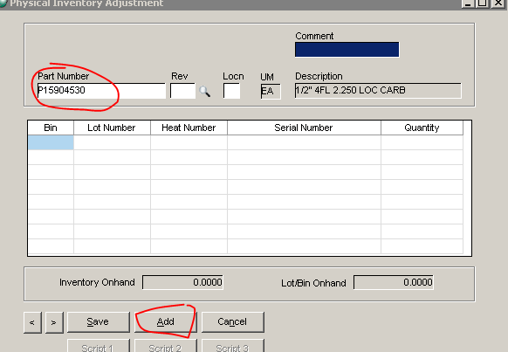

Then Fill in the Bin to TBOSS and enter the quantity on hand. If you don’t have any, you still have to enter 1 at this time. we will zero it out once you click save.

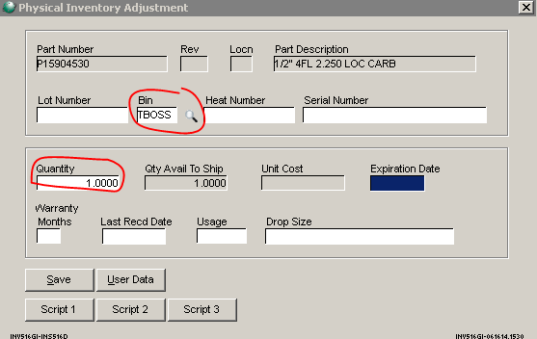

Make sure the quantity is correct and click Save. Now if you actually do not have any of these tools change the quantity to “0” (zero). You have to put a quantity in so it creates the Bin /Lot for the system

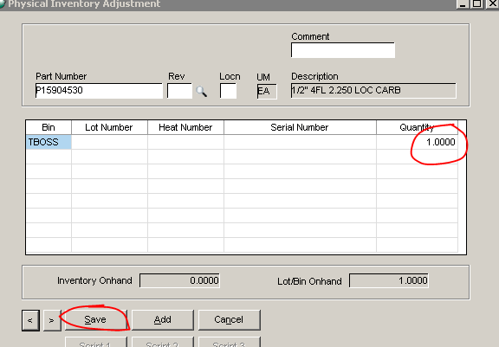

Once you click save it will move to the next part number. Just close this window at this time or leave it open if you are doing multiple parts.

Now you have to put the part into a drawer location in ToolBoss.

If you left Toolboss,

Start ToolBoss Utilities

To add a tool, click on System Configuration on the left column then click on Machine Setup in the right column

User – admin

Password – sps

Double Click the DRAWER SETUP icon

Once you do this it will pop with a diagram of the different cabinets. There is a <Select Frame> at the top of the screen, use this to scroll to the correct cabinet

Frame 1 is the original yellow cabinet

Frame 2 is the first blue cabinet -A Cabinet

Frame 3 is the second blue cabinet – B Cabinet

Frame 4 is the new yellow cabinet

Frame 5 is the third blue cabinet – C Cabinet

The list on the left is the drawers, select the drawer you want to put the tool in.

Once you select the drawer it will list the current tools in this drawer on the right side. In this case I selected the top drawer. Then click the Add Item Button

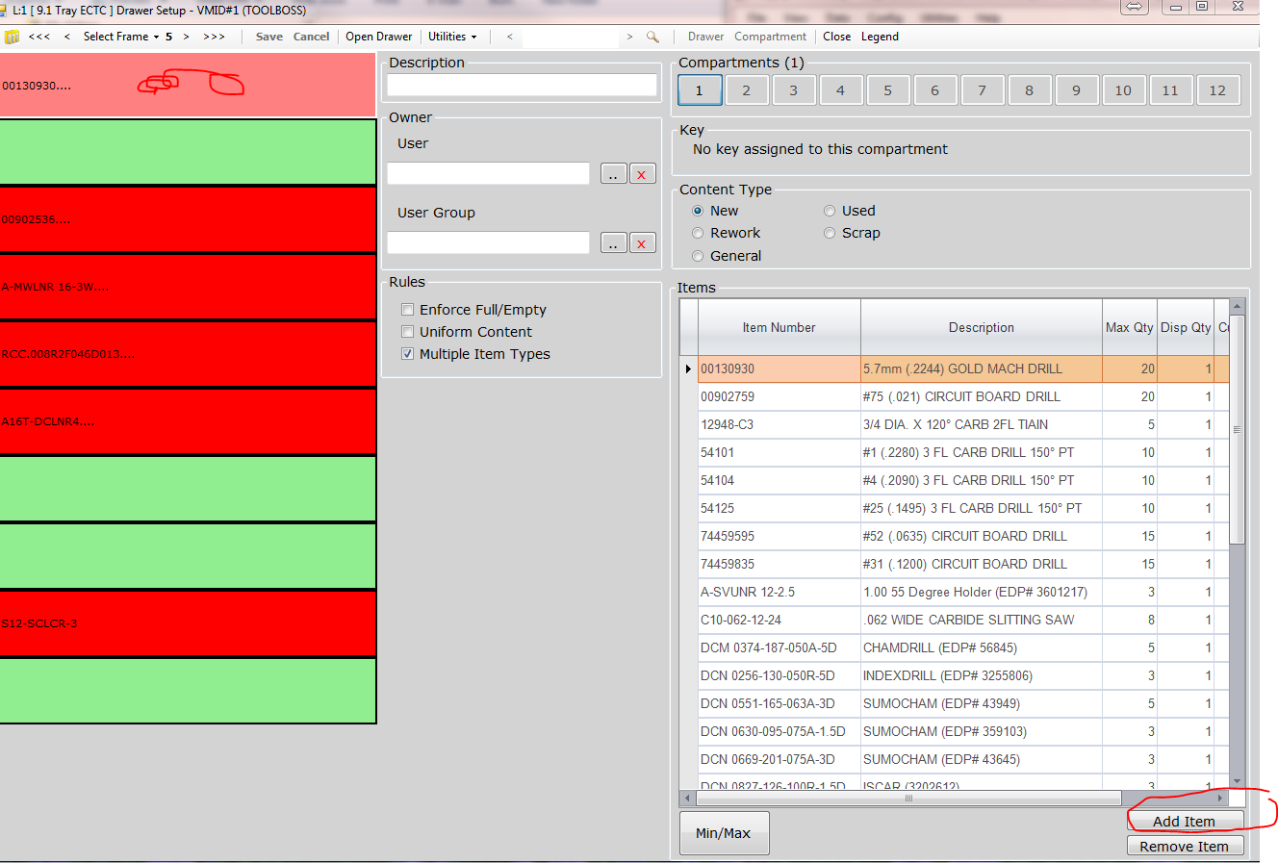

In the top search row, start typing your part number and when you see it in the grid Double click it to select it.

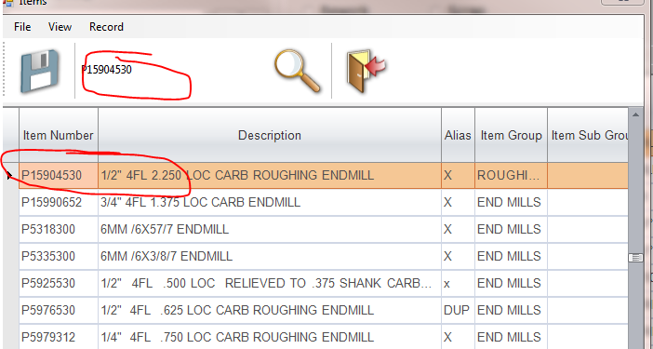

When you add the tool, it will put it at the bottom of the grid so you might have to scroll down to see it.

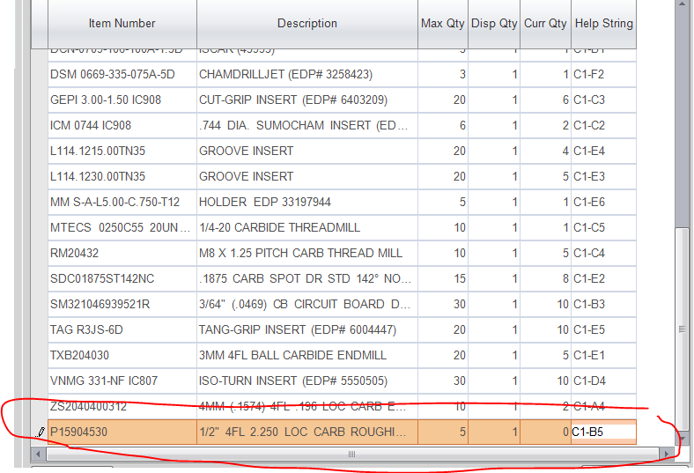

Add the MAX quantity the drawer will hold. This is NOT the min /max of the tool but how many tools the drawer location can hold. Dispense quantity should be 1, Curr Qty (Current Quantity) is how many you are putting in the drawer. I would do “0” (Zero) and then do an inventory adjustment on the tool and it will update Global shop the next morning. That way you don’t have to go back to Global Physical Inventory and adjust it again.

Then click “Save” once you have the tool entered and proceed to the next tool.

Next you need to create a label for the Bin Location. Just copy the part number and description onto the label and attach to the drawer divider

